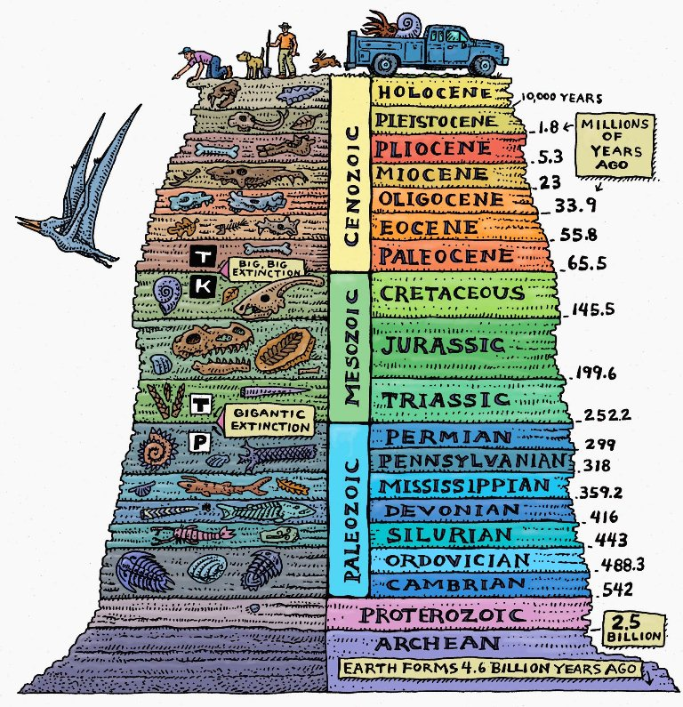
Evidence sheet 1: The fossil record:

Fossilisation occurs when an organism’s remains get buried under mud or dirt soon after its death. Once buried, decomposition of the remains slows down due to the lack of air. As the more layers of dirt get added on top of it, the remains become surrounded in stone. Finally, water makes its way into the bones, leaving behind minerals that turn the bones into stone, creating a fossil. While this is not the only way for a fossil to be created, it is one of the most common. Footprints and shells can also be fossilized by this same process.

Sadly, fossils are very rare as most organisms decompose long before they can be buried. Because of this, most fossils are found in or near oceans, rivers, and ponds, as flowing water can quickly cover any remains with mud, speeding up the process. As a result of this rarity, less than 10% of all species have fossils.

When a new fossil is found, it is added to the fossil record, which is the collection of all fossils ever discovered. Using a combination of absolute and relative dating, we can sort these fossils by age to get an idea of when each organism lived. We can also tell where a species lived simply by determining where its fossils can be found. If a fossil stops showing up in the fossil record, we assume that the species it belonged to went extinct.

About 66 million years ago, ¾ of all organisms on the planet vanished from the fossil record (they stopped leaving behind fossils) all at once. This included the dinosaurs and all large land animals. Though some large Oceanic organisms survived, most of them went extinct as well.

This event occurred across the entire planet, with species in every ocean and continent disappearing from the record at the time. The animals that continued to appear in the fossil record after this time period were mostly small animals that could dig underground and survive with very little food. The plants that continued to appear were primarily flowering plants that survive in cold, dark environments.

Definitions:
- Fossilisation: The process of becoming a fossil
- Decomposition: The breakdown or decay of a dead organism's body into nothing.
- Organism: A Living thing such as a plant, animal, mushroom or bacteria
- Fossil: Remains of an organism that have been turned into stone and preserved
- Oceanic organisms: Sea creatures like fish, sharks, jellyfish or whales.
- Vanished: Disappeared
- Species: Group of organisms capable of reproducing, such as dogs, cats, bears, trees and fish.
- Flowering plant: Plants that grow flowers

Evidence sheet 2: The Iridium Layer:

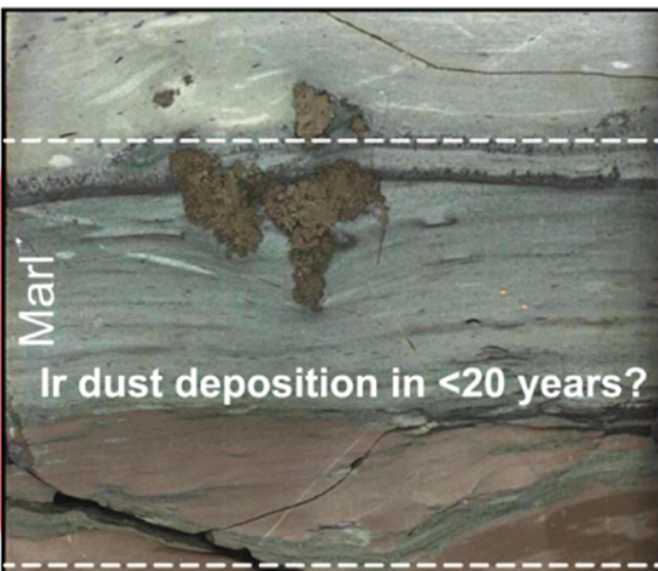

The earth's crust is made up of layers of dirt and stone formed over billions of years, with each new layer laying directly on top of the previous. As these layers are formed, materials get trapped and preserved. This allows us to use the principle of superposition directly to determine how old each layer of dirt is. Using this principle, geologists are able to label layers of dirt and rock by the time period that formed them. We can then determine the approximate age of materials simply by knowing which dirt layer it was found in.

Most of the time, materials get trapped in dirt layers while they are being formed. This can happen in several ways. Rivers, floods and tsunamis carry mud and ocean sediment across the land. Soot and other dust can be sent into the atmosphere before eventually falling back down to the ground. Dead plants and animals can become soil, rock, coal, or fossils in the right conditions.

One of the most notable dirt layers was formed around 66 million years ago and is known as the K-Pg boundary.The K-Pg boundary is unique because it contains a large amount of iridium dust, which is an element that is very rare on earth, but very common on asteroids and meteorites. Some iridium dust can be produced naturally through volcanic eruptions, however the dust would only be found locally. The iridium dust in the K-Pg boundary appears across every continent and under every ocean, which is not something that can be explained by volcanic eruption.

Iridium is not the only uncommon material found in this layer either. Soot and ash can also be found in large quantities across the globe. Ash and soot are produced by fires, fossil fuels and explosions. When released, they make their way into the atmosphere before falling down to the surface. While in the atmosphere, ash and soot reduce the amount of sunlight that reaches the earth, resulting in cooler temperatures and freezing. Unlike iridium, large amounts of ash and soot can be found in many different dirt layers as they are produced by large volcanic eruptions and massive wildfires.

Definitions:
- Preserved: Saved or Maintained
- Superposition: Objects deeper within the earth's crust are older than those closer to the surface
- Approximate: Estimate, general or relative
- Unique: Notable, special, rare or unusual
- Sediment: dust, dirt, sand, plant matter and rock that form the earth's surface.
- Locally: In the same area
- Soot: Black powder left by after some fires.

Evidence sheet 3: The Chicxulub crater:

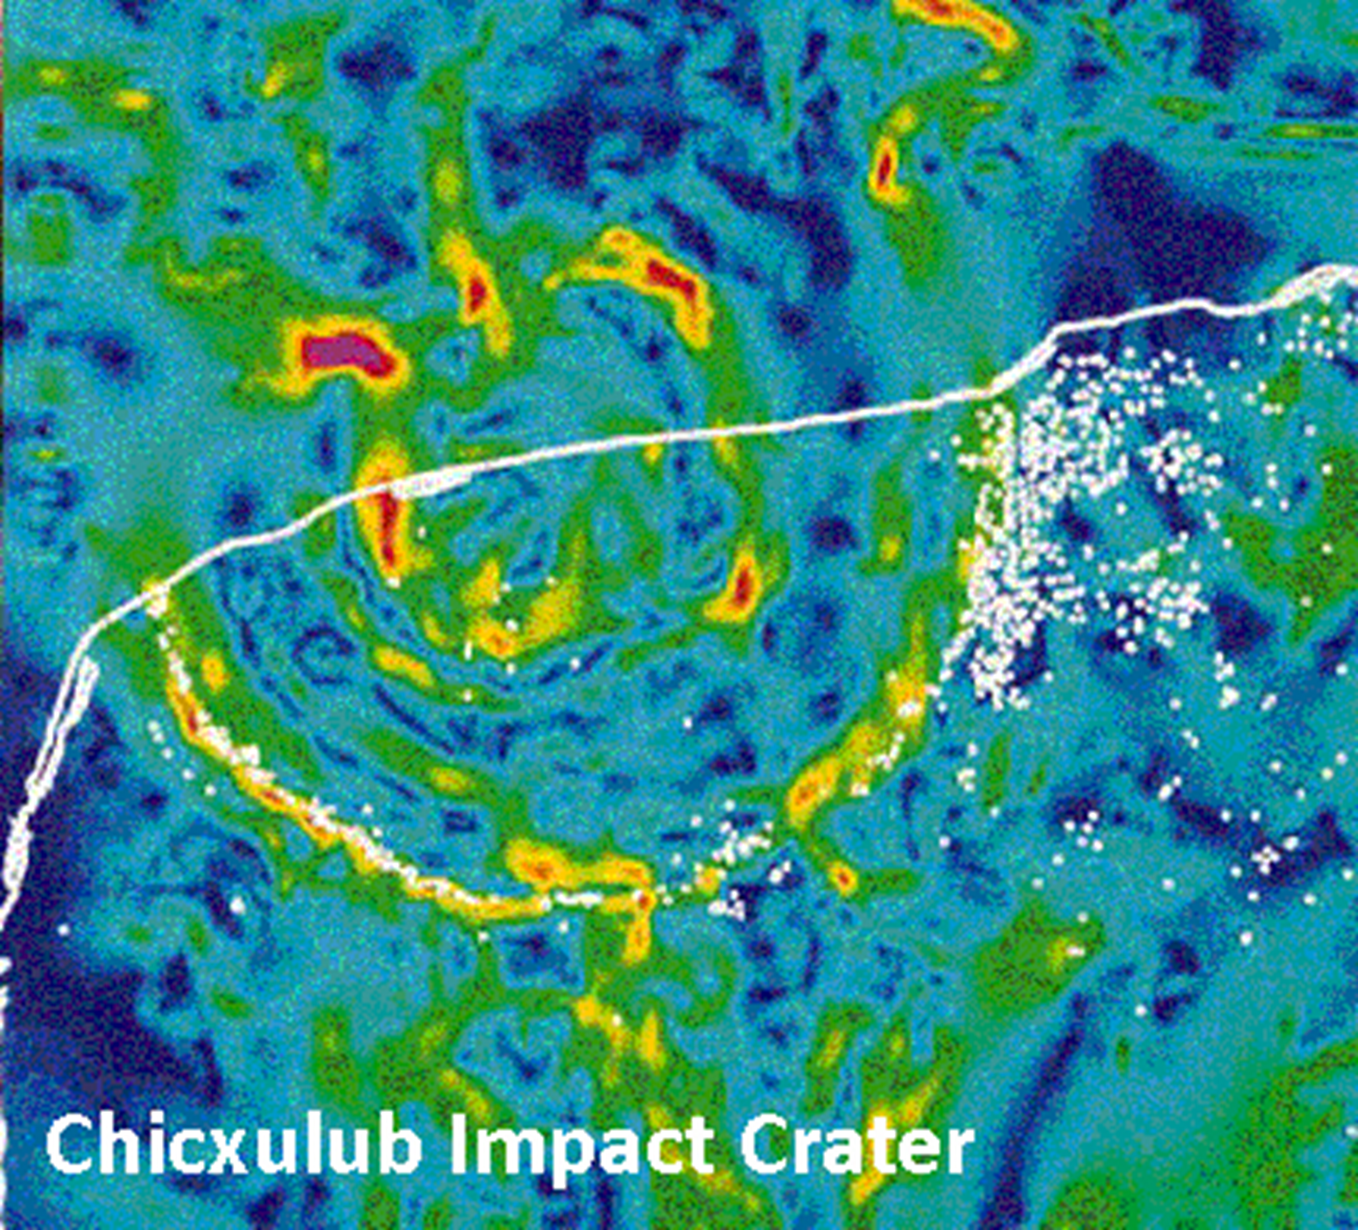

Asteroids are large objects in our solar system that orbit the sun. Most of these asteroids are made of rock or ice and can be found in the asteroid belt, which is a circular clump of asteroids located between the orbits of mars and jupiter. Most of the asteroids are kept far away from the earth by the gravity of Jupiter, but every now and then, one leaves its orbit and collides with earth.

Asteroids move incredibly quickly, so when they hit the earth's atmosphere they light nearby air on fire creating a fiery trail. Then one of three things can happen depending on the size of the asteroid. Small asteroids break apart into dust, never hitting the ground. Medium asteroids explode in mid air, producing a large amount of heat and shockwaves, potentially even triggering tsunamis or landslides. Large asteroids can survive long to impact the ground with great force.

For the largest asteroids, the impact produces an explosion that is millions of times more explosive than all man made weapons combined, often causing the asteroid itself to disintegrate on contact. This explosion sends shockwaves through both the air and the earth's crust, potentially causing earthquakes, landslides and tsunamis. The heat of the impact melts nearby rock and causes massive forest fires. The force of the impacts sends molten rock, ash and dust from deep in the earth's crust up into the atmosphere, blocking some of the earth's sunlight, cooling the planet and starving plant life. The largest asteroids can spread this destruction worldwide. As the rock near the impact cools, it forms a crater.

One of the largest craters (known as the Chicxulub crater) was found close to the shore of Mexico, buried partly under the Yucatán Peninsula. The crater is about 200 kilometers (120 miles) wide and 30 kilometers (19 miles) deep, with about half of it buried under the ocean. The walls of the crater contain a large quantity of shocked quartz and naturally formed glass, both signs of intense heat and pressure. There is also an unusual amount of iridium dust found throughout the crater. Using radiometric dating, scientists discovered that the crater is about 66 million years old.

Definitions:
- Orbit: Follows a circular path around
- Atmosphere: Gas surrounding the earth that makes up the sky
- Disintegrate: Broken into tiny pieces or turned into dust
- Molten rock: Hot liquid rock in the form of lava or magma.
- Radiometric dating: Method of determining the age of an object through radioactive decay

Evidence sheet 4: Explosion evidence:
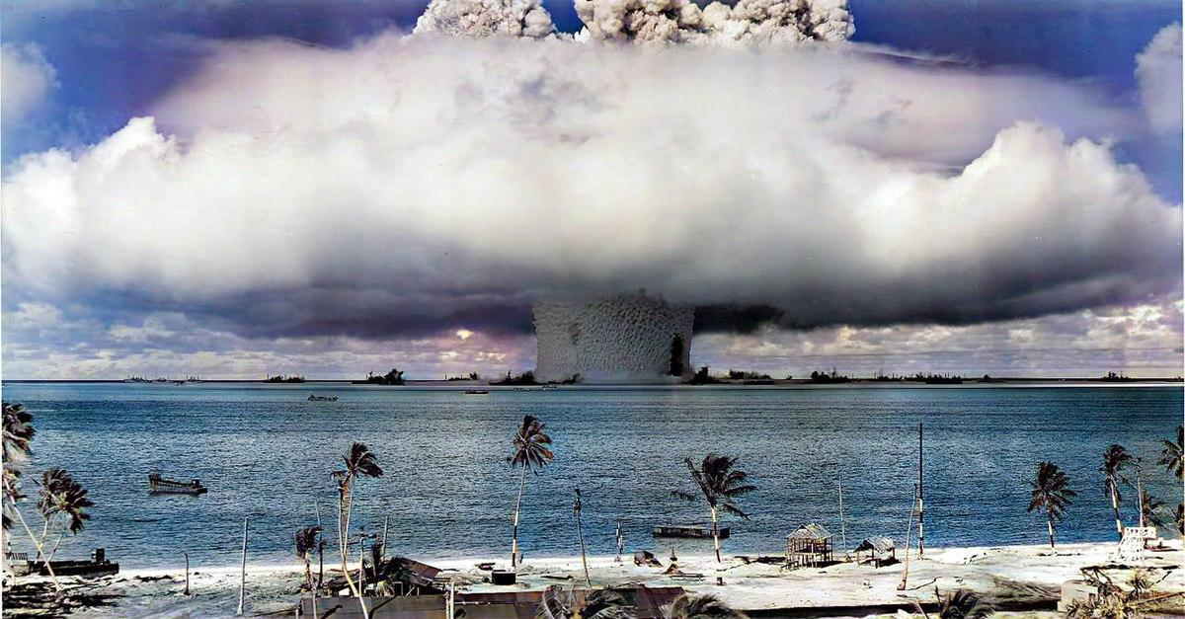

Tsunamis are massive waves of water that occur when a large amount of ocean water is suddenly displaced. While there are many ways for tsunamis to occur, the largest ones are caused by large underwater earthquakes, landslides, volcanic eruptions and oceanic asteroid impacts. The largest tsunamis, known as megatsunamis, reach over 100 meters (or 328 ft) in height. Tsunamis this large are capable of making it deep into land due to their greater force, potentially causing the extinction of any organisms living on the coast.

As tsunamis travel across the ocean, they pick up ocean sediment and carry it onto land. Using the principle of uniformitarianism, we know that tsunamis in the distant past must have done the same thing, leaving behind sediment that we can observe today. This sediment becomes trapped in a layer of Earth's crust and is easily recognizable as oceanic sediment, allowing geologists to easily determine when a tsunami occurred through the principle of superposition. Using these principles, scientists have found evidence of a megatsunami that occurred about 66 million years ago.

When looking at the dirt layer formed 66 million years ago we find large amounts of oceanic sediment on almost every coast that extends deep into the land. Geologists have determined that it would take tsunamis with waves more than 330 meters high to form this much sediment, making it one of the largest known tsunamis. It was so large in fact that it destroyed a large number of the plant and animal life on the coast, changing the environment. This all leads to an obvious question, what caused this tsunami?

Fortunately, ocean sediment is not the only piece of evidence left behind from the same time period. In the same sediment layer we can find a large amount of shocked quartz spread across the planet. Shocked quartz is formed when a quartz crystal is exposed to a high amount of pressure for a very short amount of time. There are 3 main ways for shocked quartz to be formed, lightning strikes, nuclear explosions, or asteroid impacts.Other natural disasters such as earthquakes, landslides and volcanoes simply do not provide the amount of pressure necessary for the formation of shocked quartz. Lightning is also not the cause of this layer of shocked quartz, as lightning can only create shocked quartz locally. It would take a shockwave spreading across the entire earth to form this much shocked quartz, something that even nuclear weapons cannot do.

Definitions:
- Displaced:Moved out of place
- Oceanic: In the ocean
- Organism: A Living thing such as a plant, animal, mushroom or bacteria
- Sediment: dust, dirt, sand, plant matter and rock that form the earth's surface.
- Uniformitarianism: The laws of Physics and Chemistry work the same way today as they did millions of years ago
- Superposition: Objects deeper within the earth's crust are older than those closer to the surface
- Locally: In the same area

