Humans vs. AI Game Activity:

Players Instructions
The objective of this activity is to model AI reinforcement learning through an interactive game. Students will work in groups and perform actions that will move the game piece on the game board. From these movements and their location, players will either gain, lose, or receive no change in the number of points. Students must identify the patterns to discover the policy where they can maximize the number of points. The group that attains the most points during the allotted time wins the game.

Materials:
- Blank game board
- Notes sheet
- Privacy screen (like the ones used for testing)
- Score sheet
- Counter for score sheet
- Counter for game board
- Key* (keep separate from all other materials)
*Moderators will pick up the Key from the teacher, players will set up all other materials

Preparation: Players
- The teacher will form groups of 4 - 5 people
- Dedicate one person in each team to be the Moderator. The other 4 members will be Players
- While Moderators meet with the teacher, Players will begin reading their set of game instructions titled “Player Instructions”
- Players will then set up the game board, score sheet, note sheets, counters, and privacy screen as shown below
  - Place one counter on the “START” space on the blank game board and one counter on the “0” (zero) space on the score sheet
  - Moderator will bring the Key with them after they meet with the teacher since Players are not allowed to see the Key
- Players will look over the note sheet and make sure they understand how to fill it out
- After the teacher finishes explaining, the Moderators will return to their groups
- In each team, the Players will be seated on one side of the table, and the Moderator will be on the other

Game Instructions

Before the Game: Players
- Read the instructions carefully and ask the teacher any questions you may have about the game
- Sit on the opposite side of the table from the Moderators
- Arrange the table as shown below
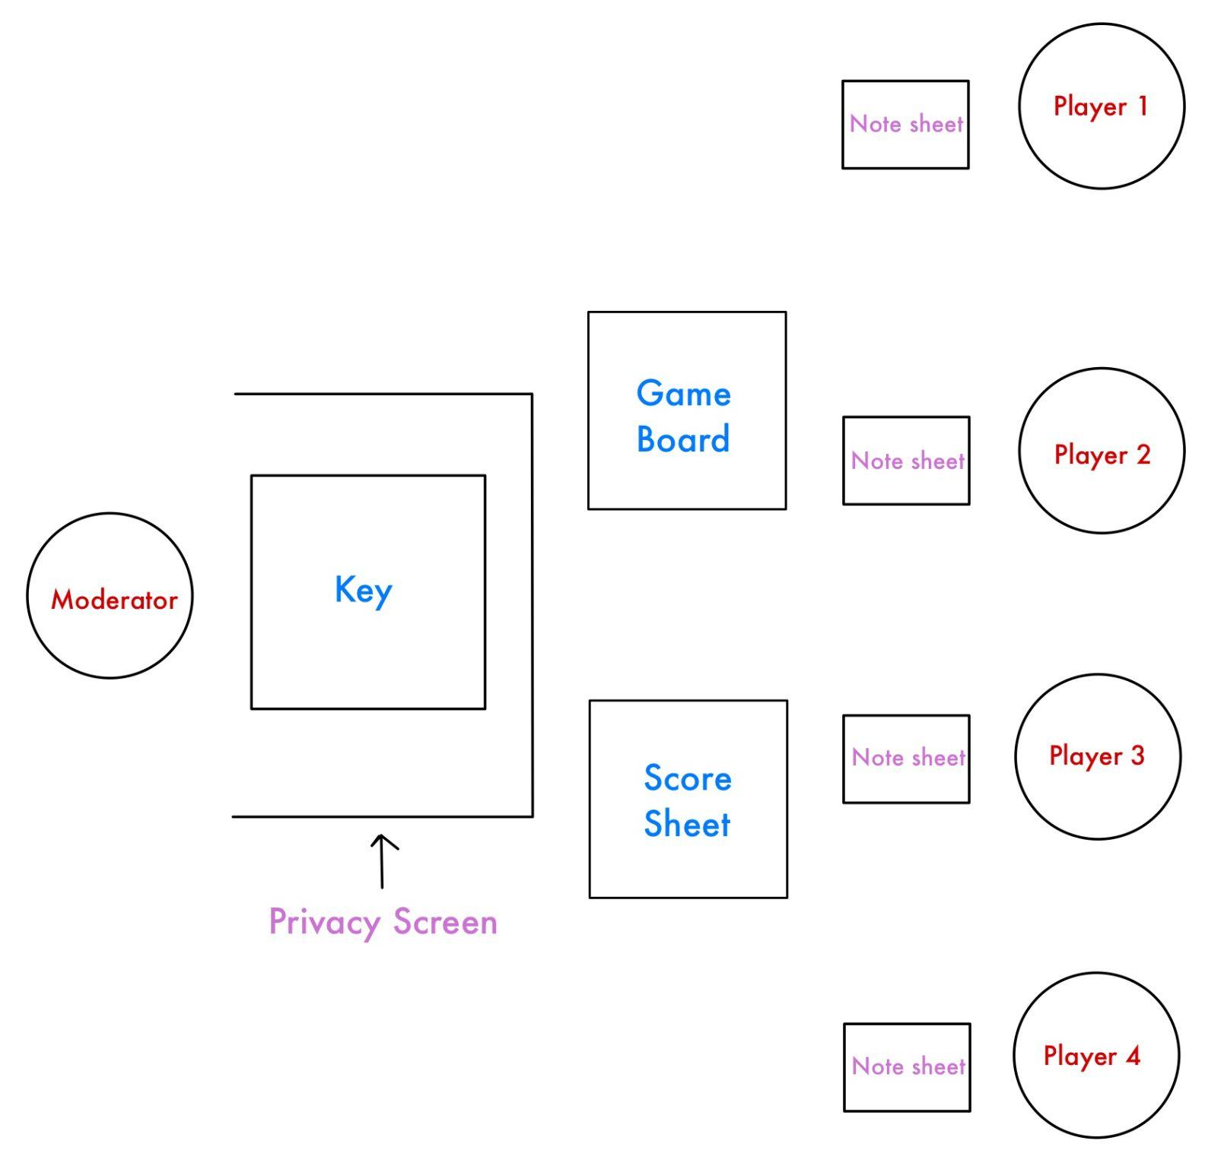

- ONLY game board and score sheet should be visible to both sides (Key should only be visible to Moderators)
- Start the game once the teacher calls time

During the Game: Players
- Once the timer starts, Player 1 (on the rightmost side) performs one of the following actions:
  - Clap
  - Wave
  - Stand
  - Snap
- Once the Moderator moves the counter on the game board and score sheet (see Step 4 in “During the Game: Moderators”), Player 2 also performs one of the actions
  - The actions do not have to be in a specific order; it is the Players’ decision which action they wish to perform
  - Players may communicate with each other to discuss a strategy
- Players will continue to take turns in order (Player 1-4, then repeat) and take note of any patterns that they notice on their note sheet

End of the Game
- The teacher calls time
- Each team reports their score according to the score sheet
- The team in the class with the most points wins

