Humans vs. AI Game Activity:

Moderator and Teacher Instructions

The objective of this activity is to model AI reinforcement learning through an interactive game. Students will work in groups and perform actions that will move the game piece on the game board. From these movements and their location, players will either gain, lose, or receive no change in the number of points. Students must identify the patterns to discover the policy where they can maximize the number of points. The group that attains the most points during the allotted time wins the game.

**Materials (per group):**

* Blank game board x1
* Notes sheet x4
* Privacy screen (like the ones used for testing) x1
* Score sheet x1
* Counter for score sheet x1
* Counter for game board x1
* Key* (keep separate from all other materials) x1

*Moderators will pick up the Key from the teacher, players will set up all other materials

**Preparation: Moderator/Teacher**

1. The teacher will form groups of 4 - 5 people
2. Dedicate one person in each team to be the Moderator. The other 4 members will be Players
3. The teacher will pass out the Moderator and Player instructions to the respective people
4. The teacher will keep the Key sheets, but give out the rest of the materials to the Players
5. The teacher will call over the Moderator from each team and explain the Moderator’s responsibility/instructions privately, ensuring that Players do not hear
   1. The teacher will ensure that each Moderator understands how to read the key and “moderate” the game
6. After the teacher finishes explaining, the Moderators will return to their groups and set up the Key behind the privacy screen as shown below
7. In each team, the Players will be seated on one side of the table, and the Moderator will be on the other

## **Game Instructions**

**Before the Game: Moderator**

1. Listen attentively to the teacher’s instructions
2. Make sure you do not reveal any critical information about the Key to the players!
3. Sit on the opposite side of the table from the Players
4. Ensure that Players CAN NOT SEE the key by setting up a privacy screen in front of the key as shown below

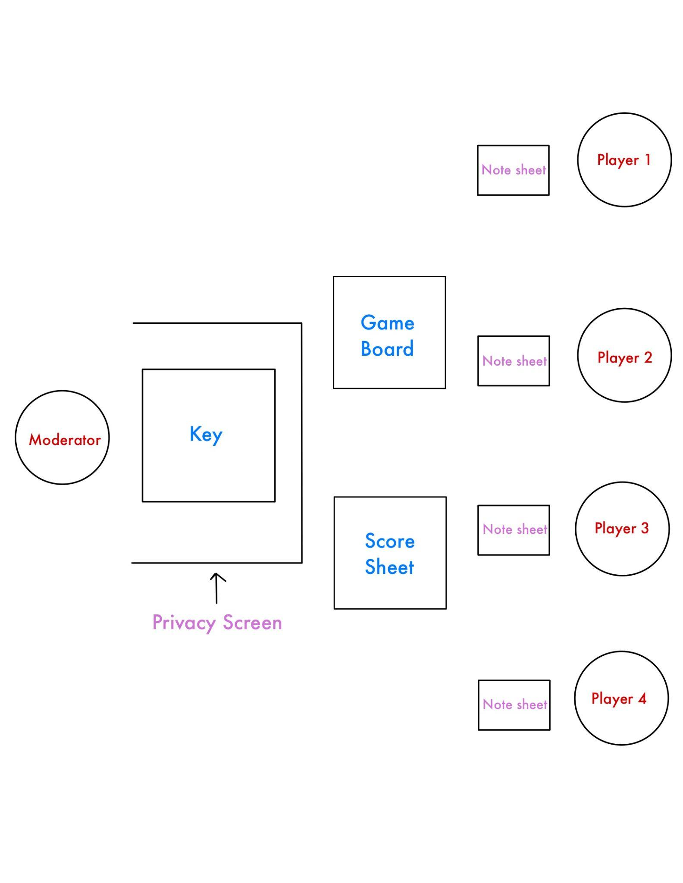

1. ONLY game board and score sheet should be visible to both sides (Key should only be visible to the Moderator)
2. Teacher will set the timer and instruct students when to start

**During the Game: Moderator**

1. Once Player 1 completes their action, follow the key and move the counter on the game board based on the players’ actions
2. DO NOT REVEAL the key to players, either verbally or by hinting; remain neutral
3. When a player performs an action, the moderator will look at the key and see how to move the counter on the game board
4. Without giving the players any hints, the moderator will move both counters; one on the game board, and one on the score sheet depending on if the players lose or gain points from the action

**During the Game: Teacher**

1. Walk around the classroom and supervise any groups that need help with understanding the instructions
2. DO NOT REVEAL the Key to the Players, either verbally or by hinting; remain neutral
3. Periodically remind the class about time

**End of the Game**

1. The teacher calls time
2. Each team reports their score according to the score sheet
3. The team in the class with the most points wins