Exit Ticket
- A Hertzsprung-Russell (H-R) Diagram is shown.
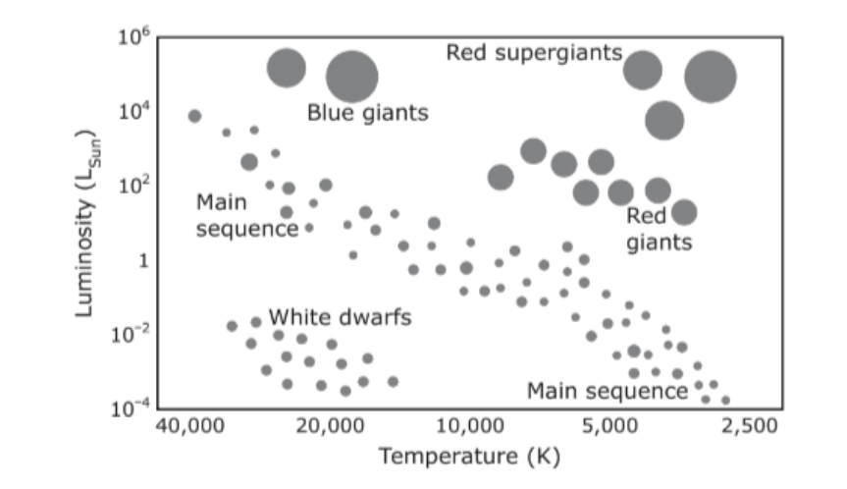
A star that has a luminosity of ${10}^{-2}$ and a temperature of 20,000 K is most likely a -

- Main Sequence
- White Dwarf
- Blue Giant
- Red Giant

- Alpha Centauri appears as a bright object visible in the Milky Way galaxy. Alpha Centauri is actually a system of three objects. Each object produces light and rotates on its own axis. The system is an average of 4 light-years from Earth.

Based on this information, the three objects that make up Alpha Centauri system are all -

- Asteroids
- Comets
- Planets
- Stars

- Which statement best describes the location of the sun in the Milky Way galaxy?
- The sun is located in the center of a spiral-shaped galaxy.
- The sun is located off the center of an elliptical-shaped galaxy.
- The sun is located on an arm of a spiral-shaped galaxy.
- The sun is located on an arm of an elliptical-shaped galaxy.

- The HR diagram shown is divided into four sections.
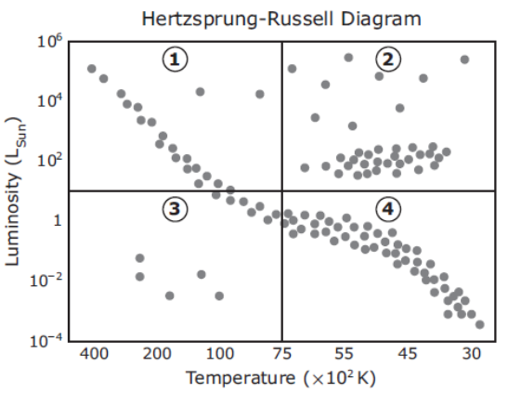
Which section of the diagram includes the coolest, brightest stars?
- Section 1
- Section 2
- Section 3
- Section 4
- The table lists the characteristics of four stars.
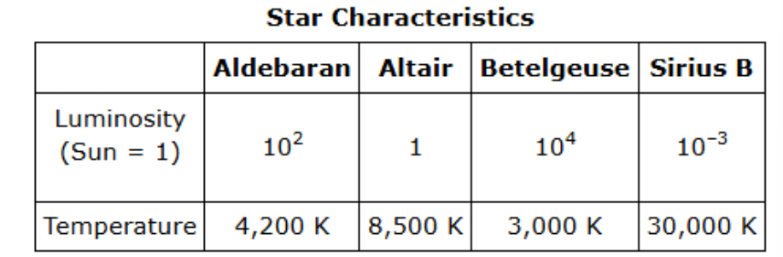
How is each star categorized in the Hertzsprung-Russell diagram?
Write each answer in its corresponding box.
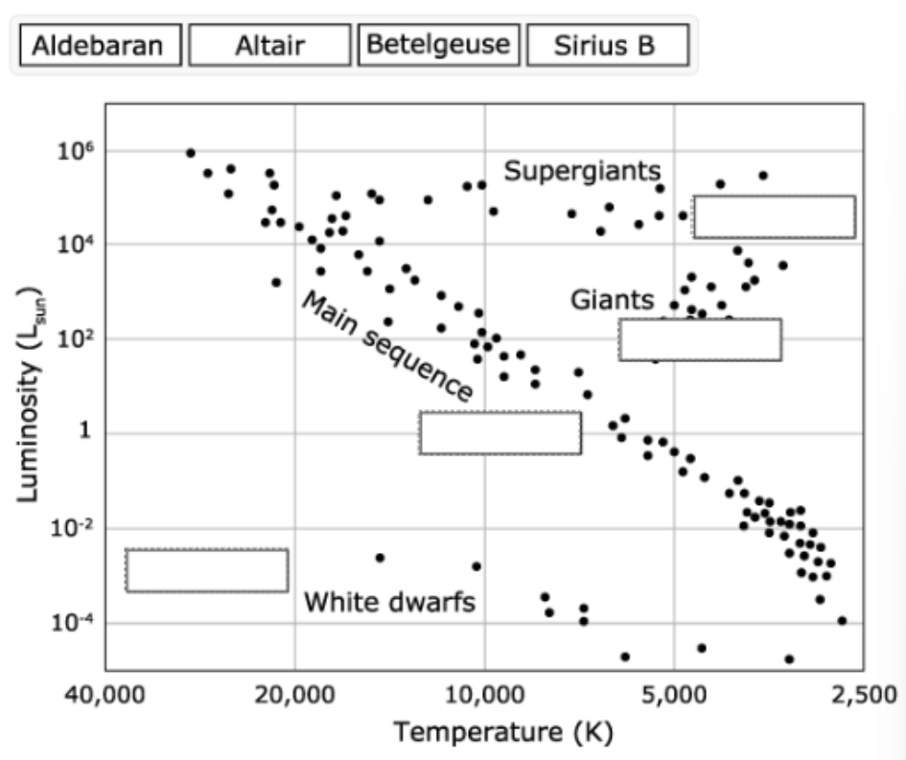
(White dwarfs = Sirius B; Main sequence = Altair; Giants = Aldebaran; Supergiants = Betelgeuse)

