CORAL REEF BIODIVERSITY READING GUIDE

Gleaming with color and light, coral reefs are among the most vibrant ecosystems on Earth. Although they only stretch across 0.1% of the sea floor, they contain an abundance of biodiversity- the variety of life in a specific region. Coral reefs support an incredible variety of life, from tiny creatures to large hunters. A reef is formed and maintained by small organisms, such as zooxanthellae, which live in collaboration with the coral. The zooxanthellae provide the food for the coral which is required for the reef structures to grow. Filter feeders, such as barnacles, anchor themselves to surfaces and filter nutrients from the water. Additionally, hunters such as grouper fish inspect caves and overhangs for prey. It is estimated that around 25-40 % of all marine species live near or within coral reefs, making them incredibly diverse and a vital part of ocean ecosystems.
Coral reefs are still considered mysterious by scientists because much of life is hidden! There are tiny animals known as cryptic animals that are so well-camouflaged that they’re almost impossible to spot—even when they’re right in front of us.
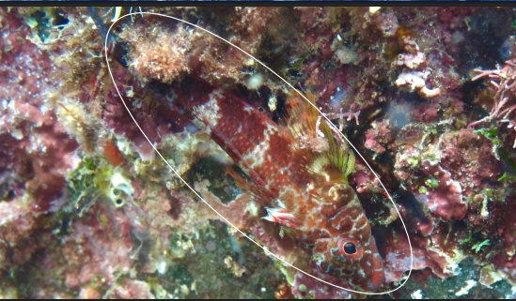
Cryptobenthic fish — “crypto” meaning “hidden” and “benthic” meaning “on the bottom” — are tiny, camouflaged species that live along the seafloor. An example of these animals is the triple fin fish. These fish have short lifespans (up to three years) but are vital to the survival of the reef. Because they are small and abundant, they play a key role in the marine food web. They act as primary consumers, feeding on plankton and other smaller organisms, and in turn provide energy to larger predators such as groupers and snappers. Through this transfer of energy from microscopic organisms to higher-level predators, triple fin fish helps maintain
Importance of DNA
How do we know there are so many unique organisms? Scientists use DNA! For a long time, scientists had to rely on looking at an organism’s physical traits to name and distinguish it from another organism. Now, with DNA analysis, scientists can observe the differences between a variety of species, even those that are invisible to the naked eye, using the organism’s genetic code.
Species Interactions and Unique Roles:
Using new DNA analysis methods, researchers discovered that many fish species once thought to be the same are distinct. Despite their similar appearance and shared habitats, they have developed specialized diets- a sign of speciation and adaptation to different ecological roles.
Each creature, no matter how small, plays a unique, specialized role in the ecosystem. A food web is a complex network of all the species interactions that illustrate the feeding relationships within an ecosystem. It is a more realistic representation than a food chain because most organisms consume or are consumed by more than one species. Predation and Competition are the driving forces that shape the food web, as they determine how energy flows and who survives to pass on their genes. These interactions, along with others such as mutualism, commensalism, and parasitism, create a complex, interconnected web of feeding relationships that define the structure and stability of an ecosystem. This means that if a species goes extinct in a local area, there may be no other species to fill its ecological role, which can destabilize the entire reef ecosystem.
The food web is built on five main ways species interact:
Interaction | Definition | Example
Predation | One organism kills and eats another. | A grouper chased and ate a small fish.
Competition | Two or more organisms fight over the same limited resources (food, territory, mates). | Two fish fighting over the same hiding spot in a piece of coral.
Mutualism | Both species benefit from the relationship. | The coral provides shelter to the zooxanthellae, and the zooxanthellae provides food to the coral.
Commensalism | One species benefit, and the other is neither helped nor harmed. | A tiny barnacle growing on a large whale.
Parasitism | One species (the parasite) benefits, while the other (the host) is harmed. | A tick or small worm living on a fish and slowly draining its resources.

Global Threats and Taking Action

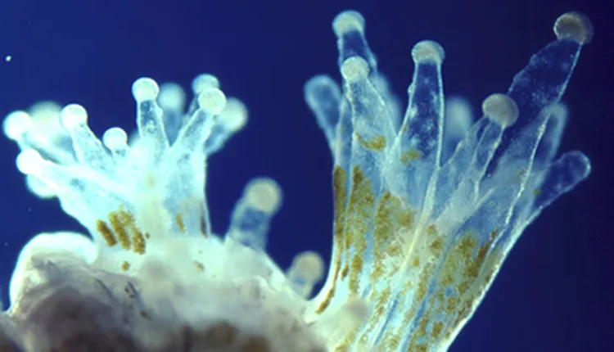
Climate Change: One of the biggest dangers to coral reefs today is climate change, particularly the warming of the ocean due to increased greenhouse gases in the atmosphere, causing unusually warm water temperatures.

When ocean temperatures rise too high, corals become stressed and expel algae that live in their tissues, called zooxanthellae. These algae give the coral its color and, most importantly, provide up to 90% of its energy through photosynthesis. When they leave, the coral turns white, a process called coral bleaching.
So, how does coral bleaching affect biodiversity and overall ecosystem stability? Coral bleaching has major effects on ocean life and the balance of reef ecosystems. When coral loses its colorful algae, it also loses its main source of energy, causing the coral to weaken and often die. As corals disappear, they take shelter and food for countless fish and other animals with them. This causes a drop in biodiversity, meaning fewer kinds of species can survive in the area. With fewer organisms and less healthy coral, the whole ecosystem becomes less stable and more susceptible to pollution and disease. Ultimately, as the biodiversity of the ecosystem decreases, so does the overall stability. If global ocean temperatures continue to rise, the coral will suffer from bleaching, and coral reefs will be overtaken by fast-growing algae. Since 1997, there have been four documented global bleaching events, causing a massive decline in live coral coverage worldwide.
Hope for Reefs

Why should we care about saving coral reefs? Coral reefs act as natural barriers that protect coasts from storms, and they aid in providing food for millions of people. The good news is that there are actions we can take to help save our coral reefs:
- Reduce greenhouse gas emissions.
- Alleviate local stressors (Protecting the reefs from pollution, overfishing, etc.).
- Restoration (Growing new corals in labs and replanting them on the reef).
One-way scientists and conservationists are helping coral reefs by focusing on the seemingly unrelated health of nearby land ecosystems. It turns out that what happens on land can have a strong impact on the ocean. A particularly successful approach involves rat eradication on remote islands. The rats posed a problem because they preyed on seabird eggs, collapsing the bird's populations and cutting off the important nutrient link between land and sea animals. When rats are removed, native seabirds return in large numbers. These seabirds' poop on the islands, and the nutrients wash into the sea, restoring the local ecosystem and making the reefs healthier within years. Therefore, protecting seabird breeding grounds provides an indirect but powerful way to help coral reefs thrive.
Ultimately, protecting reefs requires a strong policy to establish commitment and drive innovation worldwide. The survival of these vital ecosystems depends on immediate action.
READING QUESTIONS
- Zooxanthellae gives the coral its color and, most importantly, provides up to 90% of its energy through photosynthesis. What is the relationship between zooxanthellae and coral?

- A grouper is seen chasing and eating a small fish. What is the relationship between the grouper and the small fish?

- Using your answer to the question above, how would a reduction in the population of small fish impact the overall stability of the ecosystem? Why?

- A tiny barnacle anchors itself to the surface of a large whale, giving the barnacle a stable place to live without impacting the whale. What is the relationship between the barnacle and the whale?

- Given that many marine species rely on coral reefs, how would a global bleaching event affect the overall biodiversity and stability of oceans?

- The text states that the process of predation and competition are driving forces that shape the Identify two major environmental changes that negatively affect coral reefs.

