

**The Genius of Dogs Lesson Plan**

|  |
| --- |
| **Lesson Plan for Grades: 6-8**  **Length of Lesson: 90 minutes (Can be split into two 45 minute sessions)** |
| **Authored by:** UT Environmental Science Institute  **Date created:** |
| **Subject area/course:**   * Biology |
| **Materials:**   * “From wolf to dog” reading handout * “Domestic Research” handout |
| **TEKS/SEs:**  RULE §112.28 Grade 8, Adopted 2021  4. describe how variations of traits within a population lead to structural, behavioral, and physiological adaptations that influence the likelihood of survival and reproductive success of a species over generations.  §112.27 Grade 7, Adopted 2021  12: Organisms and environments. The student knows how systems are organized and function to support the health of an organism and how traits are inherited. The student is expected to:  (D) describe and give examples of how natural and artificial selection change the occurrence of traits in a population over generations. |
| **Lesson objective(s):**   * Students will be able to determine the difference between domesticated animals, Tame Animals, Feral Animals, And Wild Animals. * Students will be able to explain how artificial selection leads to domestication. * Students will be able to explain why behavioral traits like friendliness towards humans are beneficial to the survival and reproductive success of a domestic species. |
| **Differentiation strategies to meet diverse learner needs:**   * The teacher should ask students whether they prefer to read or watch videos to learn about concepts; then have students learn in their preferred learning style. However, the teacher may assign students certain methods to improve their skills. For example, if a student prefers reading, teachers may have them watch a video and take notes to improve their listening skills. * ELL students and students with learning disabilities should have multiple forms of instruction including visual and written instruction sheets as well as a verbal instruction and demonstration. * There is a simpler version of this lesson plans reading activity designed for english language learners * For the elaboration activity, teacher my choose to differentiate by assigning simple animals like cats or dogs to groups |
| **ENGAGEMENT (10 minutes)**  The teacher will start the lesson by opening the genius of dogs [slideshow](https://docs.google.com/presentation/d/1lvdneHRi3ICFwbIdF7L1qDt8lOrLGyNFV7JKHhkV_DU/edit?usp=sharing). Students will work in small groups to create a diagram comparing dogs and wolves.  Then the teacher will lead a short class discussion to create a venn diagram for the entire class. Watch the video from the *Hot Science - Cool Talks* comparing the behaviors of wolf pups and dog pups. Students evaluate if they want to add or remove anything from their diagrams based on the video. |
| **EXPLORATION (20 minutes)**  Teacher will pass out a reading on how wolves were domesticated into dogs(from wolf to dog reading activity). This reading will contain questions for students to answer. For the first 10-15 minutes, students read and work on the questions on their own. Following this, students discuss the reading and the questions with their table.   * During this time the teacher should walk around to answer any questions students might have and ask probing questions. |
| **EXPLANATION (15 minutes)**  The teacher will then go over slides 4-9 on the slideshow with the class. Some slides require extra guidance.   * Slide 5   + The teacher will ask students if they can notice a pattern in the differences between dogs and wolves, and if they can explain why that pattern is. * Slide 7:   + Each of the traits common to domesticated organisms can be related to dogs through the venn diagram on slide 5 * Slide 8:   + If possible the teacher should write down 4 to 5 of the jobs the students come up with on the board/boards. Under each job, students should write down traits that they think would be important for dogs in that job to have. |
| **ELABORATION (20-60 minutes)**  Students will be split up in groups and asked to research an organism that we have domesticated. They will be asked to answer the following questions about the chosen organism:   * Around what time did we start domesticating the organism? * How did we domesticate it? * Where was it first domesticated? * Are its wild counterparts still alive today? * How has its genetics changed since we domesticated it? * How has its behavior changed since domestication? * What does the domesticated organism do for use?*Ie: Does it produce food, Do manual labor, Serve as transport etc.*   If the students are having trouble choosing an organism they can pick from the following list.   * Honey bees * Cows * Bananas * Fancy mice * Camels * Wheat * Cats * Cabbage   During this time students will fill out the “Domestic Research!” worksheet.  Alternatively, if time allows, students can prepare a presentation on their chosen organism. This presentation would be done in front of the class and it should include the following elements.   * Visuals such as a slideshow or paper poster * The answers to the research questions   Each presentation should last between 3-5 minutes |
| **EVALUATION (throughout entire lesson)**  The worksheet provided for the elaboration section will serve as a good measure of the students' understanding. |
| **SOURCES AND RESOURCES**   * List any sources you referenced to create this lesson plan, and if relevant, include the full web addresses for them. * Dr Brian Hare ***Hot Science – Cool Talks #131,* “The Genius of Dogs”** |

Additional resources

* <https://www.seattleschools.org/wp-content/uploads/2022/03/AVID_Instructional_Strats.pdf>

**From wolf to dog**

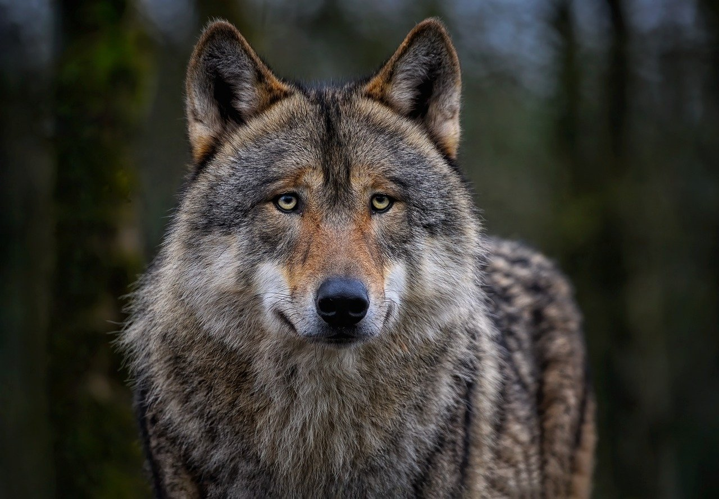

|  |
| --- |
| What do you think reproduction means?  What might natural selection mean in this context? |

Wolves are relatively timid creatures, preferring to avoid any animal that is not partof their pack. While wolves are effective hunters in groups, they struggle to fight anything their own size or larger alone. Ancient wolves who left the pack were less likely to survive on their own, likely dying before they could have children and pass on their genes. As a result only wolves who stuck with their pack and avoided unnecessary confrontation were able to pass on their genes and behaviors through **reproduction**. *This is an example of the process known as* ***natural selection****.*

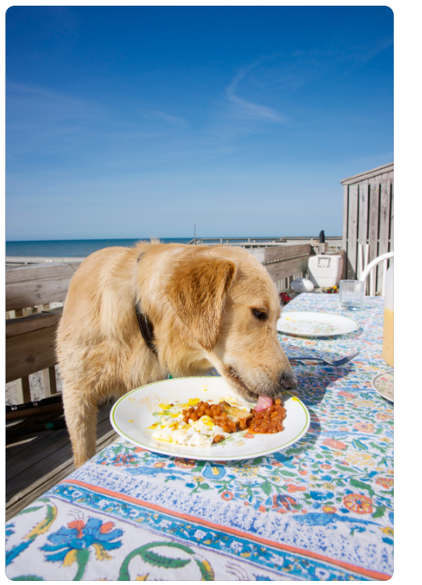

Things began to change once humans arrived. One thing that humans have always been great at is leaving behind piles of trash wherever they go, trash that tends to attract animals. Today, we find bears, raccoons and flies invading our dumpsters, but 15,000 years ago it was wolves. After all, we hunted the same things, so it makes sense that our leftover food would be appealing to wolves. Wolves are relatively smart animals, so a few of the braver ones found that they could get free food if they approached human camps in a docile (friendly, non threatening) manner. Once we rewarded this **behavior** by allowing them to eat our food, they came back for more. Eventually, the approaching wolves would then

see humans as both a source of food and shelter, so they stuck around and started to treat humans as part of their pack, effectively **taming** themselves.

|  |
| --- |
| What could it mean for an animal to be tame? |

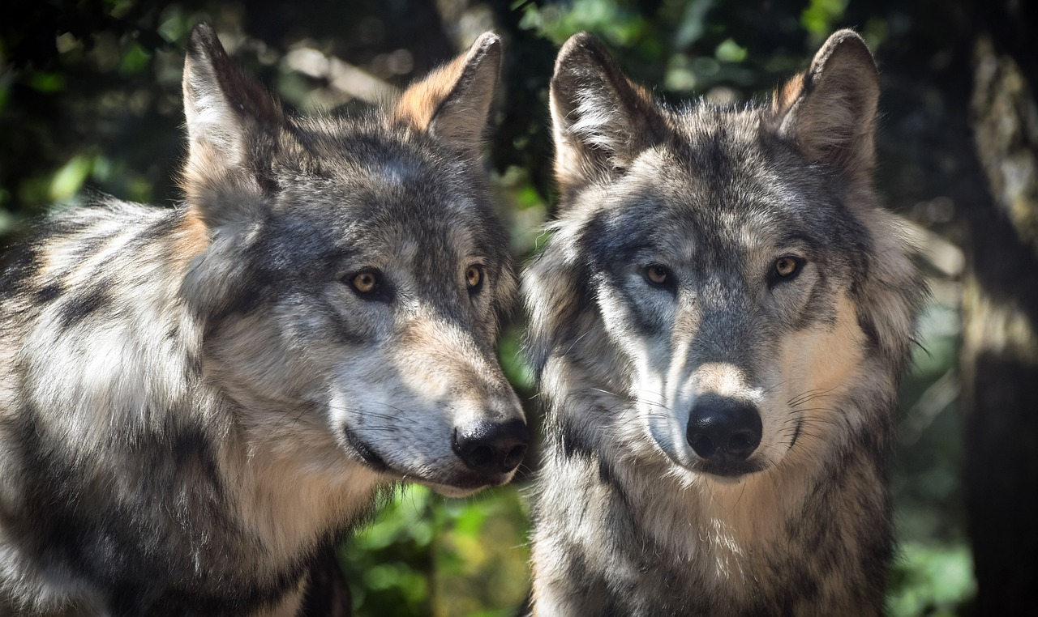

Wolves are **social animals**, prefering to do everything with their pack. Once those ancient wolves saw humans as part of their pack, they began to join us in hunting, eating, and even sleeping. Furthermore, wolves are fiercely loyal to their packs willing to risk their lives in defense of the humans who fed them, forming a **mutualistic** relationship. Wolves got food, shelter, water, safety and even companionship, while humans got companionship, protection, and help hunting.

|  |
| --- |
| What of the following relationships is a mutualistic relationship?   * One organism benefits while the other is harmed * One organisms benefits while the other is unaffected * Both organisms benefit * Neither organism benefits |

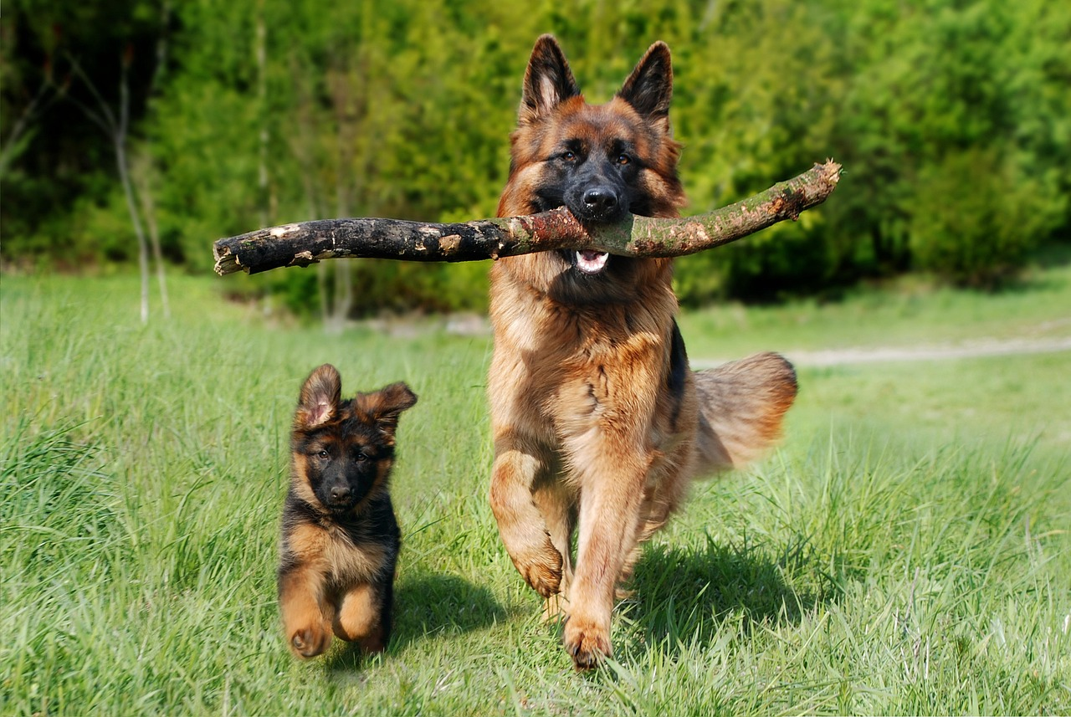

Over hundreds of years, the descendants of these wolves became completely reliant on humans, even allowing us to choose their mates. Eventually, humans started to choose which genes and behaviors were passed through reproduction. Through this process of **artificial selection**, humans bred the descendants of those wolves to be cuter, giving them shorter snouts and more playful personalities. Humans also bred them to do specific tasks for us like hunting, herding, and pulling sleighs. After thousands of years, dogs became so different from wolves that they could no longer be considered to be the same species, solidifying their domestication.

|  |
| --- |
| Based on the article, what do **you** think it means for an animal to be domesticated? |

**From wolf to dog ELL**



|  |
| --- |
| What do you think reproduction means?  What might natural selection mean in this context?  Natural selection is the process by which… |

Wolves are shy animals that try to stay away from other animals that are not in their pack. They are good hunters when they work together, but a single wolf has a hard time fighting bigger animals. A wolf who leaves its pack usually cannot survive long enough to have babies. Wolves who stayed with their pack and avoided fighting alone were able to live and pass on their traits through **reproduction** (having kids). This is an example of **natural selection** ( Living things with features that help them survive are more likely to have children.)



Things started to change when humans arrived. Humans leave trash behind and trash attracts animals. Today, we see bears, raccoons, and flies in our garbage, but 15,000 years ago, wolves were in our trash. Since humans and wolves eat the same things, it makes sense that wolves would want to eat our leftover food. Wolves are pretty smart, so the brave ones figured out that they could get free food by calmly going to human camps. When humans allowed them to eat, the wolves came back for more. Over time, these wolves began to see humans as a source of food, shelter, and friendship so they stayed close and started treating humans like family. This is how they began to **tame** (become friendly towards humans)themselves

|  |
| --- |
| What could it mean for an animal to be tame?  A tame animal is a wild animal that… |

Wolves are **social animals**, meaning they like to do everything with their family. Once these wolves saw humans as part of their family, they started to join us in hunting, eating, and even sleeping. Wolves are very loyal to their group and would even risk their lives to protect the humans who gave them food. This created a **mutualistic relationship** where both sides helped each other. Wolves got food, shelter, water, safety, and friendship, while humans got friendship, protection, and help with hunting.

|  |
| --- |
| What of the following relationships is a mutualistic relationship?   * One organism benefits while the other is harmed 😀😞 * One organisms benefits while the other is unaffected 😀😑 * Both organisms benefit😀😀 * Neither organism benefits😑😑 |

Over many years, these early dogs became fully dependent on humans, even letting us choose their mates. Eventually, humans started to choose which features and behaviors we wanted to pass on. Through this process, called **artificial selection** (humans choose which wolves have children), humans made these early dogs look cuter, with shorter noses and more playful personalities. Humans bred these dogs to do special jobs like hunting, herding, and pulling sleds. After thousands of years, dogs became so different from wolves that they were no longer the same species, making their **domestication** complete.

|  |
| --- |
| Based on the article, what do **you** think it means for an animal to be domesticated?  An animal is domesticated when… |

Domestic Research!

|  |  |
| --- | --- |
| Name: | Date: |
| Group member names: | |
|
| Chosen organism: | |
| Time of domestication: | |
| Method of domestion: | |
| Location(s) of domestication: | |
| Does the organism still have wild relatives today? If so, what are they? | |
| How have the genetics and the behaviors of the organism changed under domestication? | |
| What does the organism do for us?(minimum of 2 things)  1.  2.  3.  4.  5. | |
| List 2-3 fun facts about your organism. | |

**RUBRIC FOR ASSESSMENT**

|  |  |  |  |  |
| --- | --- | --- | --- | --- |
| **Criteria** | **1** | **2** | **3** | **4** |
| From wolf to dog  reading actively | Questions were not answered | Questions were answered mostly incorrectly | Questions were answered mostly correctly | Questions were answered correctly |
| Domestic research  (Worksheet) | The worksheet was not completed | Answers were or incorrect | Answers were correct but vauqe/limited | Answers were correct and detailed |
| Domestic research  (Presentation) | Student did not participate | Information was missing | All information was included but the presentation was either too short or too long | All information was included and the presentation took 3-5 minutes |